RESUME
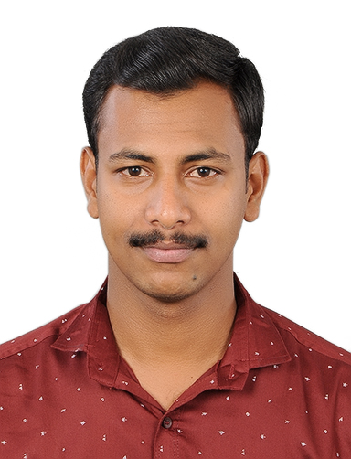

MOBIN JOSEPH Contact : +91 8089727060
: +91 8606329663
Mail-id: mobin22j@gmail.com

OBJECTIVE:

To succeed in an environment of growth and excellence to earn a job which provide me job satisfaction and self-development and help me to achieve personal as well as organizational Goal.

ACADEMIC DETAILS:

Degree/Course | University/Board | Institution | Year of Passing | Percentage
BBA | Bangalore university | Koshys Institute Of Management Studies , Bangalore | 2017 | 60
H.S.E | Board of Higher Secondary Examination  Kerala | St. Thomas English Medium Higher Secondary School , Kumily | 2014 | 75
S. S. L. C | Board of Secondary Examination  Kerala | St. Thomas English Medium Higher Secondary School , Kumily | 2012 | 78

FIELD OF INTERESTS:
- H.R
- Finance
- Marketing

WORKING EXPERIENCE
- One Year experience as Product Executive in Popular Hyundai

- Six months experience as QUALITY AUDITOR TRAINER in OYO Rooms

SKILLS:

- Time management.
- Communication.
- Ability to work.
- Decision making.

STRENGTH:

- Time Management.
- Willing to learn new things.

HOBBIES:

- Watching movies.
- Roaming with friends.

PERSONAL DETAILS:
Fathers name : Joseph A.M

Mothers name : Molly Joseph

Address : Arackaparambil (H)
Attappallam P.O,
Kumily,
Idukki
Pin: 685509

Date of birth : 22-01-1995

Gender : Male

Marital Status : Single

Nationality : Indian

Language Known : English, Malayalam, Tamil.

DECLARATION:

I hereby declare that the above mentioned are true to the best of my knowledge.

Place:

Date: MOBIN JOSEPH

